Upcoming Events:
There will be a no-cost pancake breakfast on National Pancake Day, Feb 28 for our membership from 9-11 or until the pancakes run out. Breakfast is being sponsored by the Okanagan Château.

A no-cost income tax clinic will be held at the Centre on Mondays from 9-12 starting March 4 and ending April 29. This is a service for low-income singles and families with simple returns.

Sign up for Beginners Bridge Lessons at the front desk. Cost is $75 for 8 two hour classes

Tai Chi classes will be starting Saturday, Feb 3 from 10-11am. This is an introduction to Chen style Tai Chi for 10 weeks at a cost of $20 for 10 classes. Please register at the front desk.

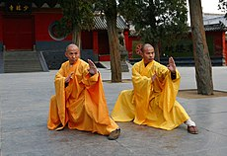
Chen Taiji is a traditional style of Taiji that embodies the practical application of natural body movements and the universal laws of yin yang to foster mind-body personal health. The emphasis is on coordinating muscle movement, releasing body tension while being grounded and maintaining balance.
Suitable for all ages, participants will learn foundation exercises and the beginning moves of the Taiji form.
Participants are encouraged to wear comfortable loose clothing and soft sole flat footwear.

Volunteer opportunities!
Do you have fun planning events? The society is looking for a volunteer Event Organizer to work with the Board on some event ideas for the upcoming year.
The success of our center relies on volunteers. Let Catherine Thompson know if you are able to volunteer; call 250-765-3723 or email rsac@telus.net . Please consider volunteering.

Fun facts about Bridge
- An early version of the game was played in England as far back as the 16th Century.
- There are two kinds of bridge, rubber which is normally played at home for leisure, and duplicate bridge which is used for competitions.
- Mrs Anthony Fly, of Little Rock, Arkansas, filed a petition for divorce, on the grounds that her husband refused to make up a four at bridge.
- However, it could be a mistake to play with your husband or wife, as shown by Myrtle Bennett. In 1929, Myrtle shot and killed her husband over his bidding and play of a hand. Mrs Bennett was later acquitted!
- The modern form of contract bridge was invented in the Twenties by American billionaire Harold Vanderbilt, who developed an early scoring system for the game.
- The odds against four players each holding all thirteen cards in a suit are 2,235,197,406,895,366,368,301, 559,999 to one. Such a deal was first claimed in March 1892, and has been claimed ever since! Maybe winning the lottery isn't so difficult after all.

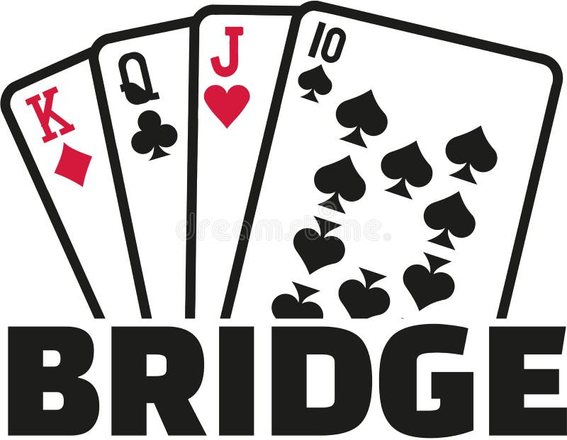
Anyone who stops learning is old, whether at twenty or eighty. Anyone who keeps learning stays young. The greatest thing in life is to keep your mind young. Henry Ford

Rutland Senior Activity Centre donated $10,000 back into our community. Catherine Thompson and Irma Sutherland presented cheques to Taco Dog Rescue, Central Okanagan Community Food bank, Seniors Outreach and Resource Centre, and Lend a Paw Pet Food Foundation.

